1. There are 2 signals I2C protocol use to send and receive data between devices: SCL and SDA. SCL (serial clock) is used as a clock for the protocol communication so both master and slave uses it as clock reference for synchronization when transmitting data. SDA (serial data) is for sending conditions such as START and STOP condition, transmitting data, and receiving ACK bit from the slave. such that each SCL cycle one bit will be transferred through the SDA.
2. A high-to-low transition in SDA while SCL is high is a START condition, notifying the receiver the serial communication will start. A low-to-high transition on the SDA while the SCL is high defines a STOP condition, signaling the end of serial communication.

Timing diagram:

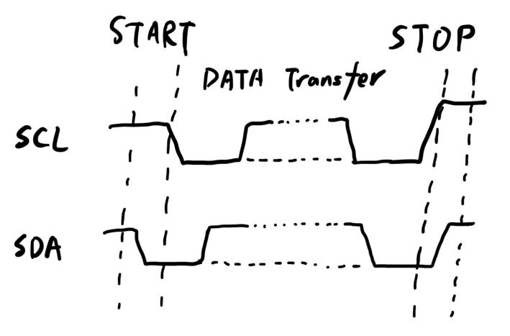

1. The maximum frequency for the SCL signal for the ADT7420 temperature sensor is 400kHz.
2. After 8 bits of data, the slave device will send back an ACK, because 8 bits is a byte and master will release SDA after sending each byte.
3. Default temperature output is 13 bits.
4. There are four bus addresses we can use for ADT7420. Although serial address is 7-bits, the first 5 bits are hardwired to be 10010 so we can change A1 and A0 to either 0 or 1 when communicating with the sensor to set the address. Therefore, there are in total 4 different addresses we can set for temperature sensor. There are more than 1 address so we can connect 4 different devices through I2C to collect information from 4 different devices at the same time.